**ENSF 619**

**Project II – Fall 2020**

*M. Moussavi, PhD, P.Eng*

This project must be completed in teams of four. You (and your partners) will analyze, design a simple, **console-based application**, and its associated database, using a Process and Data-Oriented approach (**not object-oriented**). Note that your application must have a ``two-tier architecture'' (application layer and database layer).

**Problem Statement: Requirements-based Testing**

Organizations have learned that the best software tests come directly from the software requirements. The more you know about the requirements, that is, the better you can test the system. In this case, the customer organization is a development shop that wants to adopt requirements-based testing but slowly. They don't want to try to change too much, and they don't want to spend a lot of money on commercial requirements management tools. Instead, they want a small and simple application that enables key personnel to register requirements and the test scripts that prove the requirements are satisfied. They have identified a small number of requirements to start from. Joe, the System Analyst and Shirley, the Owner of the company are to be the customers on your project.

You have taken them out for dinner one evening to chat about the proposed system, and here is a brief note on the conversations in this session:

**Joe:** We have a number of projects on the go, typically 5 or 6. Sometimes, we even have 10 projectsactive at any one time.

**Shirley:** True, and each project is either PLANNED, IN PROGRESS, or COMPLETED from ourperspective. So, this proposed system isn't for current projects only; we want to retain the history for each project.

**Joe:** When we start a project, the first thing we do is identify a pile of system requirements. Theseare high-level needs that our customers have identified. Typically, they are not very good at articulating requirements, so we help them a lot by making sure that the requirement is non-ambiguous, measurable, attainable and relevant.

**Shirley**: Each project has many requirements. Each requirement has a short title so that we canrefer to it quickly later, a brief description, and a detail description. The originator can be of our users, one of our analysts, or in the case of a design constraint, it might be one of our architects. Anyone can really be an originator, but we like to keep track of the source of each requirement.

**Joe:** I think that covers what we want to do for requirements. Our next idea is to create test scriptsthat perform test cases for one or more requirements. That is, we like test scripts to test more than one requirement. On smaller systems under test (SUT), we might even want only one test script to run test cases for all the requirements. The usual case will be that one test script checks for defects against a set of related requirements. These test scripts will have a title and a description. There is lots more that we could store here, we know that, but for now we want to keep it simple.

**Shirley:** And don't forget that one requirement could actually be tested from two or more testscripts. This usually won't happen, but we don't want to rule that out either. We want some flexibility here. Remember the goal of testing is to discover defects, not to prove that a system works. That just might mean that we want to have the same tests running in various different usage scenarios or patterns.

**Joe:** That's a good point, Shirley. Why I remember when you didn't know anything about testing. And nowlook at you, you probably know more than me. You must have been studying.

**Shirley:** Continual learning, that's my motto. The last thing we have to talk about is recording the results oftest runs. We want to be able to prove in a court of law that we have run adequate tests on our software. As a trial, we'd like to use this same database to store the results of our test runs, even if they fail.

**Joe:** Right. We're thinking that a test run is for one script and one script only. We will run the same scriptmany times though. We want to record the tester, the time and date of the run, and the results of the test every time the test script is run. By the way, it's OK if that time and date of the run defaults to the time that the tester recorded the test run. We're not that picky. The results of the test is either PASSED or FAILED. There are no other possible results that we want to record at this time.

**Shirley:** I think that covers it. Can we eat now?

**Total mark:** 40 marks

**Due Date:** Tuesday December 8, before 11:59 PM.

**Deliverables:**

Your team must submit one report in PDF format that contains

* **Statement of Purpose:**
  1. The description of system under study and its purpose**.**
* **Flow of events list**
  1. Major List of events that shows a terminator triggers something or requests for something
* **Context diagram**
  1. System and its surroundings
* **Data Flow Diagrams (DFD), level 1 and level 2. Your DFDs must:**
  1. use standard notation for process, data flow and data store as indicated in the course notes
  2. your data flow diagrams, and context diagram must be balanced
  3. show data stores, as needed
  4. when using labels and notations be consistent in all levels
* **Entity Relationship Diagram (simple ERD, with simile crowfoot lines – no rhombus on the line). Your ERD must:**
  1. Be Normalized

1. Have major attribute/columns o Have Primary Key
2. Foreign Key, if needed

**Questions for Moussavi:**

1. Potential differences between our DFD Level 1 and the DFD Level 2?
   1. Level 1 is already very detailed
2. How to indicate foreign and primary keys on an ER diagram?

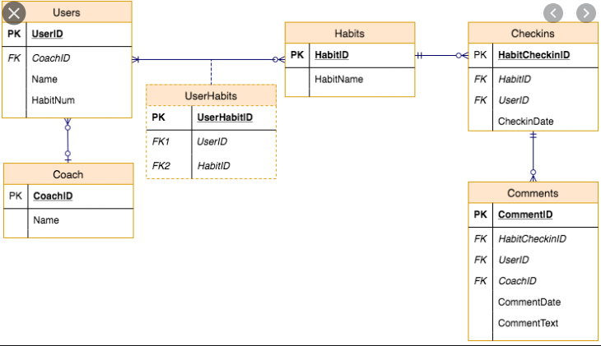

Chronological Events (from perspective of business logic)

1. Receive high-level system requirements from customer to start planning a project
   1. Has
2. Elicit lower-level requirements from originators
   1. Needs short title, brief description, detailed description
3. Create test scripts for requirements
   1. Need a title and description
4. Implement requirements
5. Run test scripts on requirements
6. Record test script results in database
   1. Needs a tester, time and date of run, result of the test
7. Make any necessary changes to the system and repeat steps 5 & 6 as needed?